Dutch Police Internet Forensics compliant registration system

System Overview:

1. This System will allow the user to register a complaint in the system
2. This System will allow the user to register for the first time in the system
3. This System will allow police to register in the system to access a separate function from the system
4. This system will allow the police user to search through complaint stored in the system
5. This system will store the data in encrypted database
6. This system will use MFA to authenticate users

System Security Function:

1. Encrypted database
2. User input details are validated
3. Incorrect inputs are not accepted
4. User will need OTP to access the system

Options Menu

**********************************

Press 1 for New Complaint Registration...

Press 2 for Existing user login

Press 3 for Police Member login

Press 4 for Exit

***********************************

Enter Your Choice [1 or 2 or 3]

## Option 1: ##

** New Complaint Registration **

When the user enters option 1, it will ask the user to enter the following information

1. First Name: {Only Alphabet with minimum 2 and Maximum 15}
2. Last Name: {Only Alphabet with minimum 2 and Maximum 15}
3. Date of Birth: {Format yyyy-mm-dd}
4. Password: { 8 < 16 > characters long and contain at least one letter from each set [A-Z][a-z][1-9][~!@#$%^&*]*****}
5. BSN: {Format 111-111-1111}
6. Address: {minimum 5 characters and maximum 50 characters}
7. City: {minimum 2 characters and maximum 20 characters}
8. Zip: {minimum 4 characters and maximum 10 characters}
9. Date of Crime: {Format yyyy-mm-dd}
10. Date of Crime Registration: {Format yyyy-mm-dd}

The below screenshot displays the case number generation and user name created for the future logins.

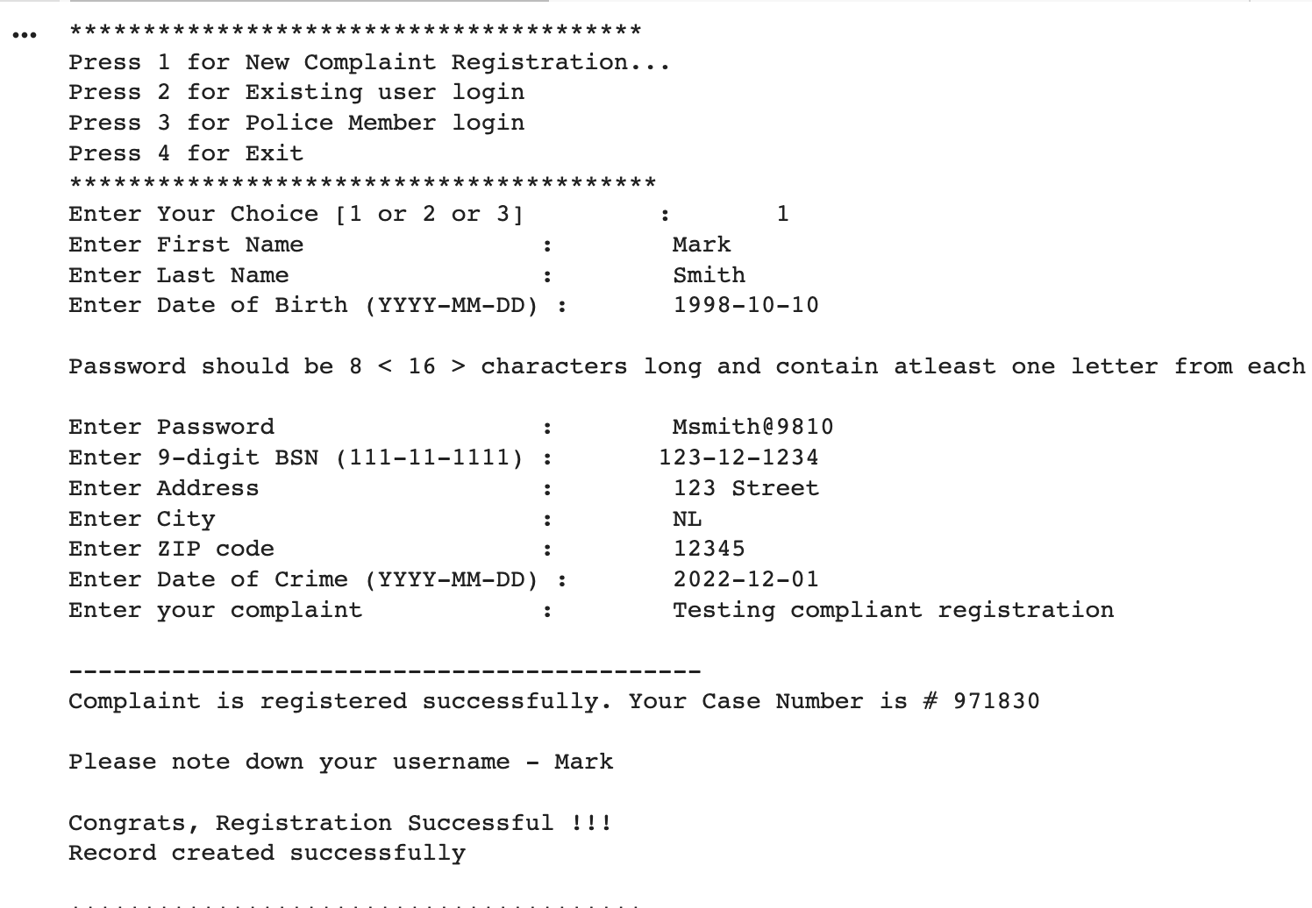

## Option 2: ##

** Existing User Login **

When the user enters option 2, it will ask the user to enter the following information

1. User Name:
2. Password: {minimum 8 characters with alphabet, numeric and special character}
3. OTP: {Only numeric characters}

The below screenshot displays the already created user able to authenticate using the credentials. The OTP is generated as part of MFA design to allow the user to navigate to the search menus.

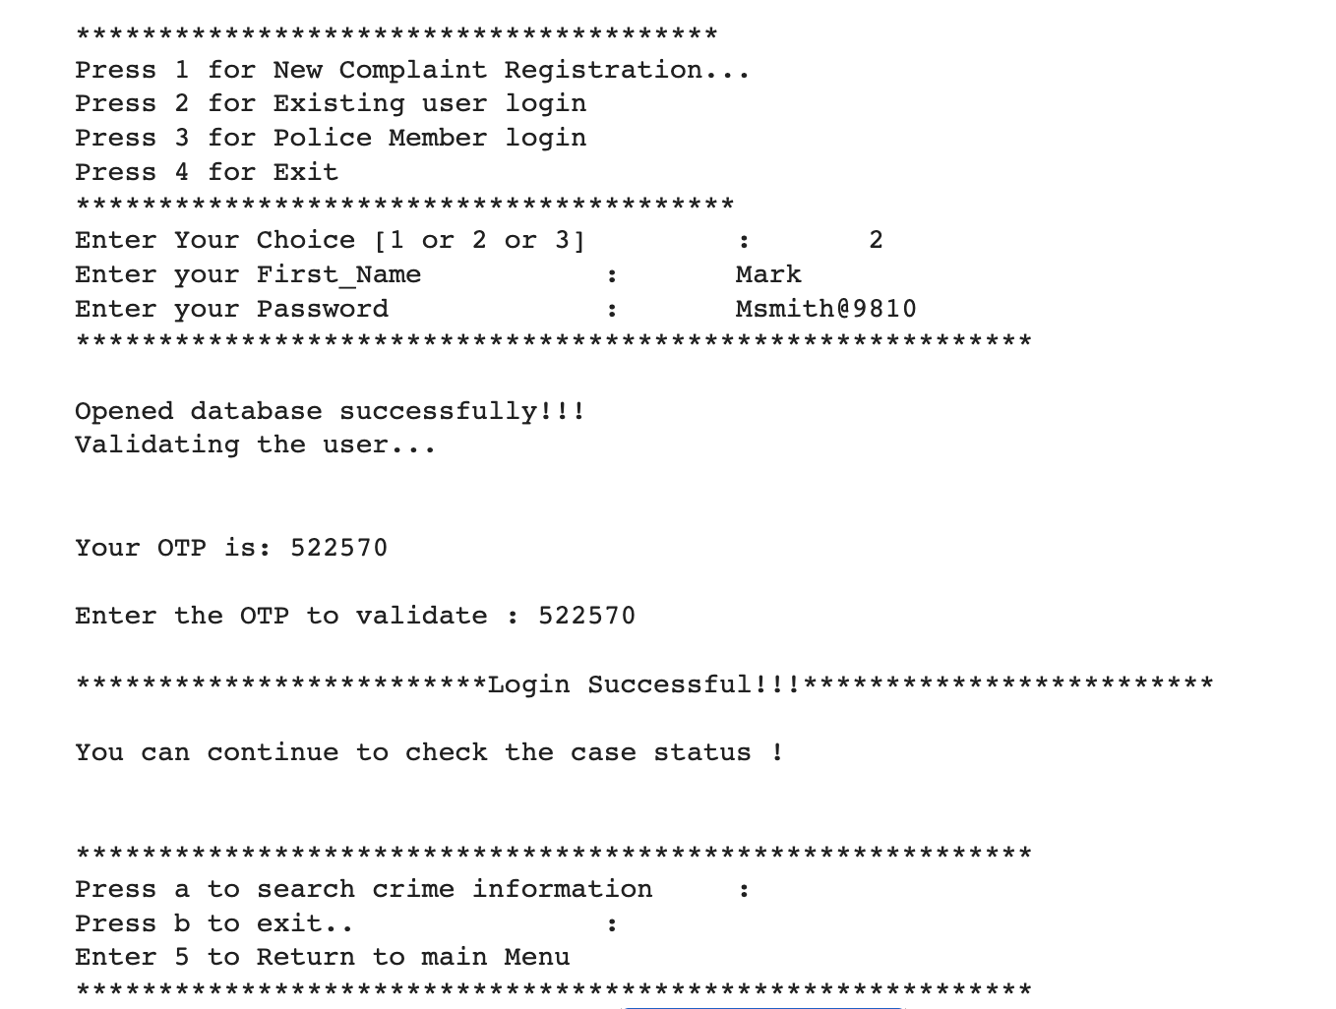

When the existing user login successful using OTP then the crime search option allows to view the status as showed in the below screenshot.

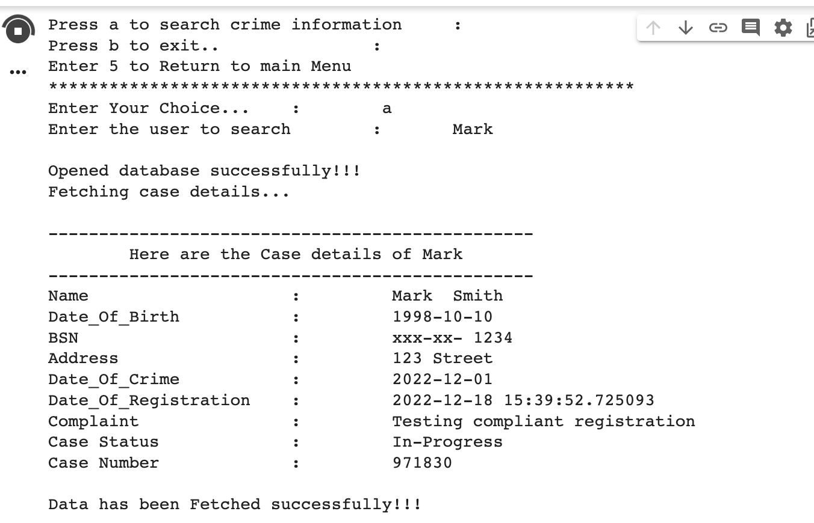

## Option 3: ##

** Police Member Login **

When the user enters option 3, it will ask the user to enter the following information

1. First Name: {Only Alphabet with minimum 2 and Maximum 15}
2. Last Name: {Only Alphabet with minimum 2 and Maximum 15}
3. Date of Birth: {Format yyyy-mm-dd}
4. Password: { 8 < 16 > characters long and contain atleast one letter from each set [A-Z][a-z][1-9][~!@#$%^&*]*****}
5. BSN: {Format 111-111-1111}
6. Address: {minimum 5 characters and maximum 50 characters}
7. City: {minimum 2 characters and maximum 20 characters}
8. Zip: {minimum 4 characters and maximum 10 characters}

The below screenshot shows the Police officer’s account created successfully by choosing option 3 and a respectively.

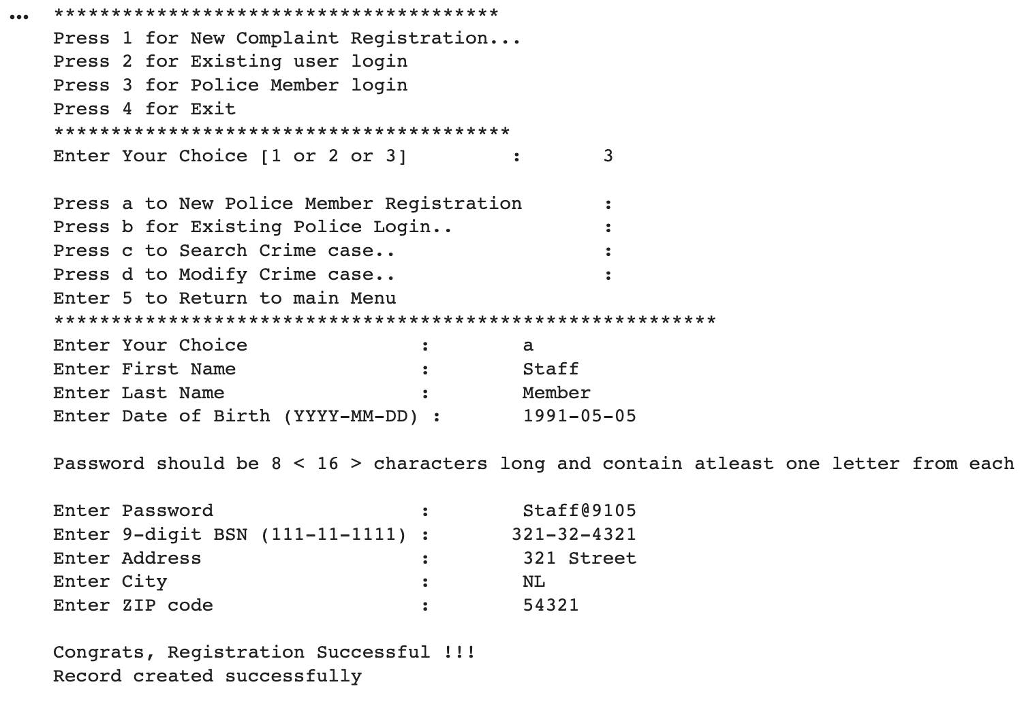

The below screenshot displays the already created Police user able to authenticate using the credentials. The OTP is generated as part of MFA design to allow the user to navigate to the search and modify menus.

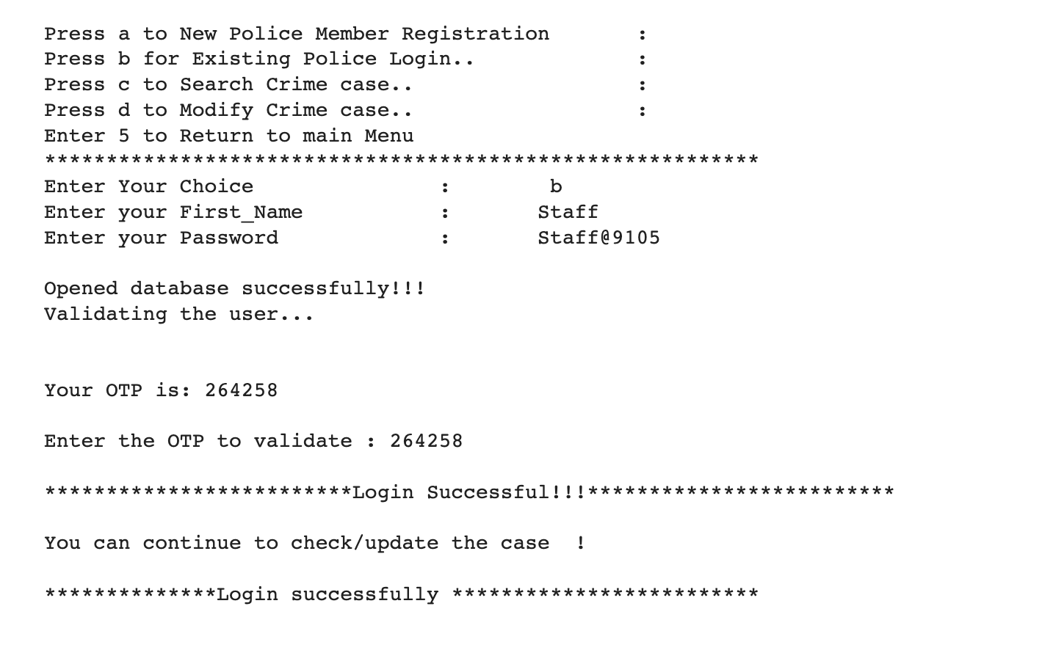

The below screenshot shows the Police staff able to retrieve the crime case.

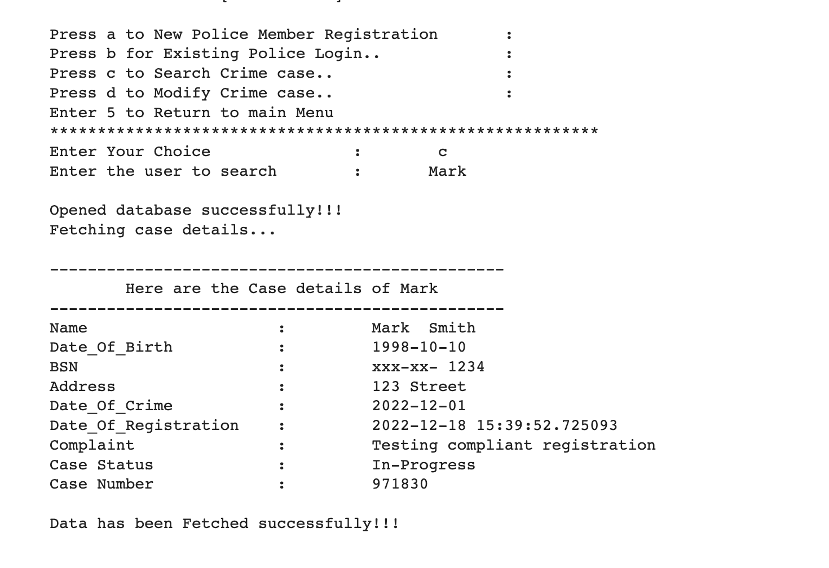

The below screenshot shows the Police staff able to update the status.

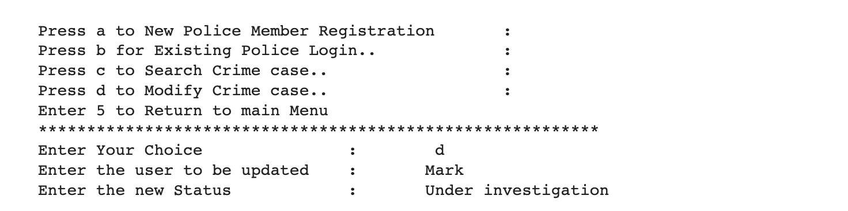

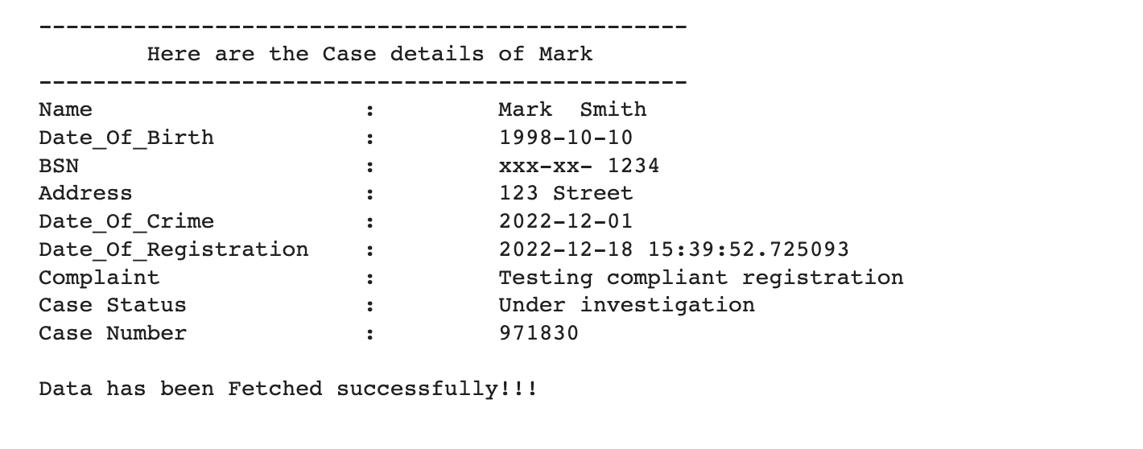

## Option 4: ##

** Exiting the system **

## **Negative Test Scenarios** ##

The below screenshot shows the error in creating a new complaint due to the discrepancy in username criteria.

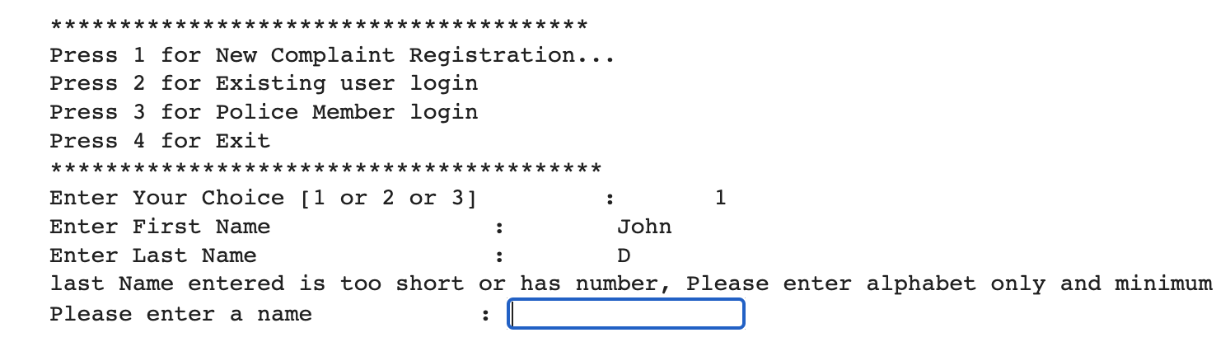

The below screenshot shows the error in date of birth format.

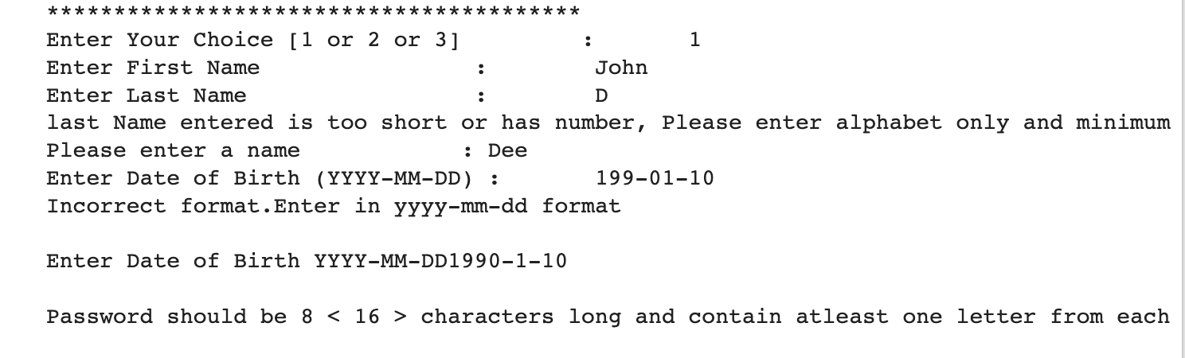

The below screenshot shows the error in the incorrect BSN number entry.

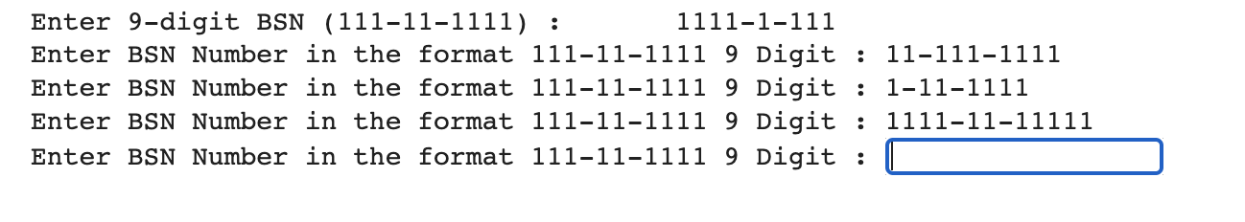

The below screenshot shows an error due to the wrong password.

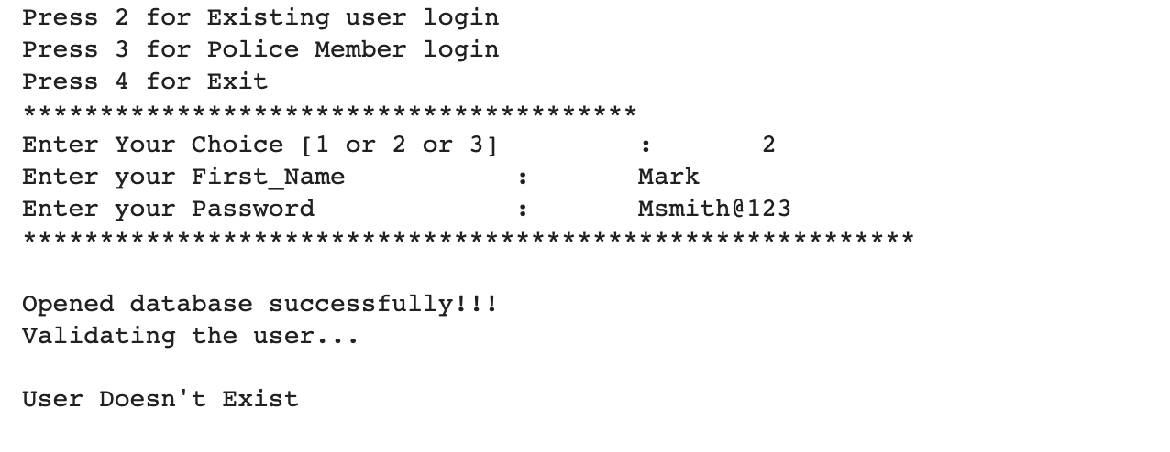

The below screenshot shows an error due to invalid last name.

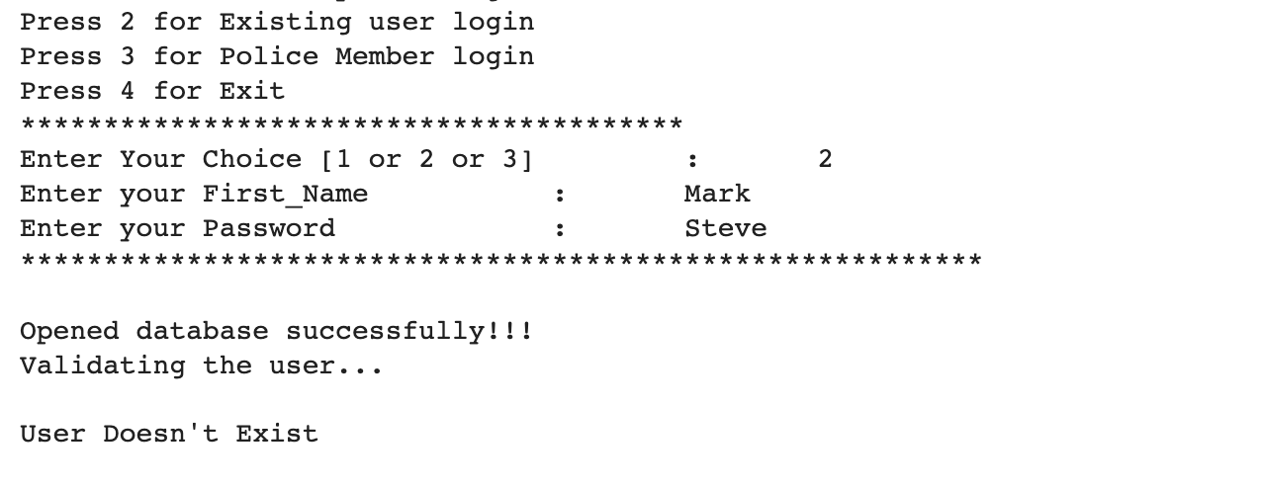

The below screenshot shows the error due to OTP mismatch.

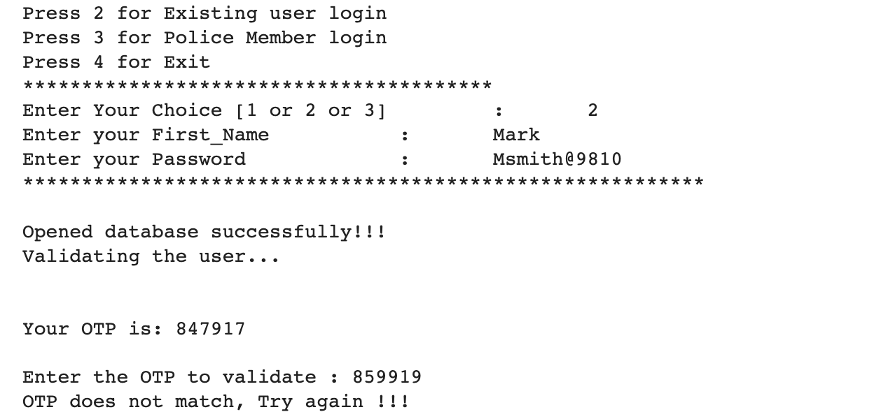

Linter validation:

We got the score of 6.92 out of 10 as shown in the below screenshot.

We reviewed our code using the linter, the few observations related to unused variables and libraries which has been removed during the development stage.

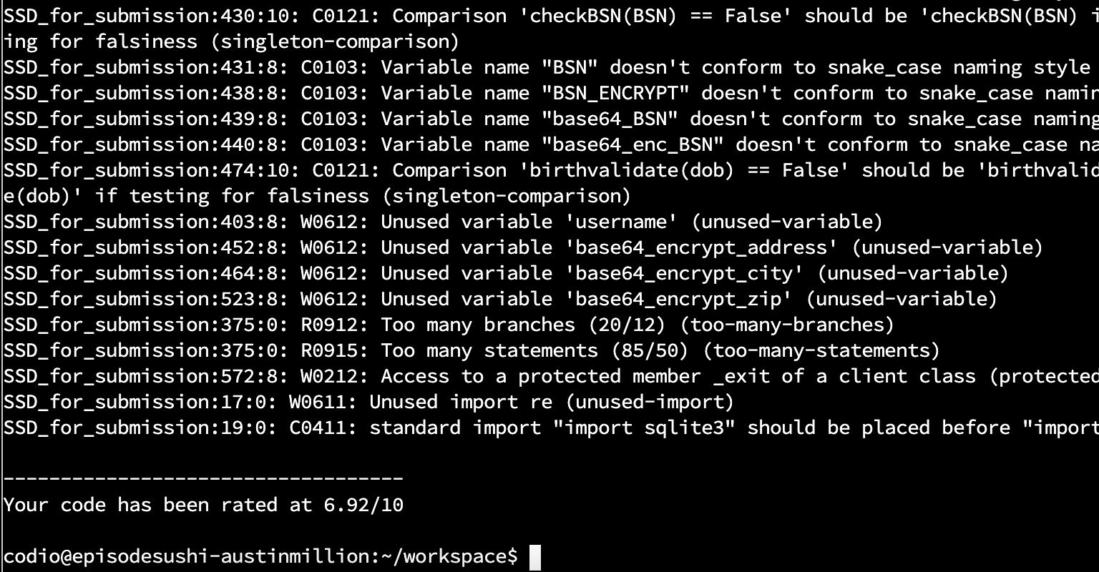

The below shown error are fixed in the final version of the code submitted as shown in the above screenshot.

